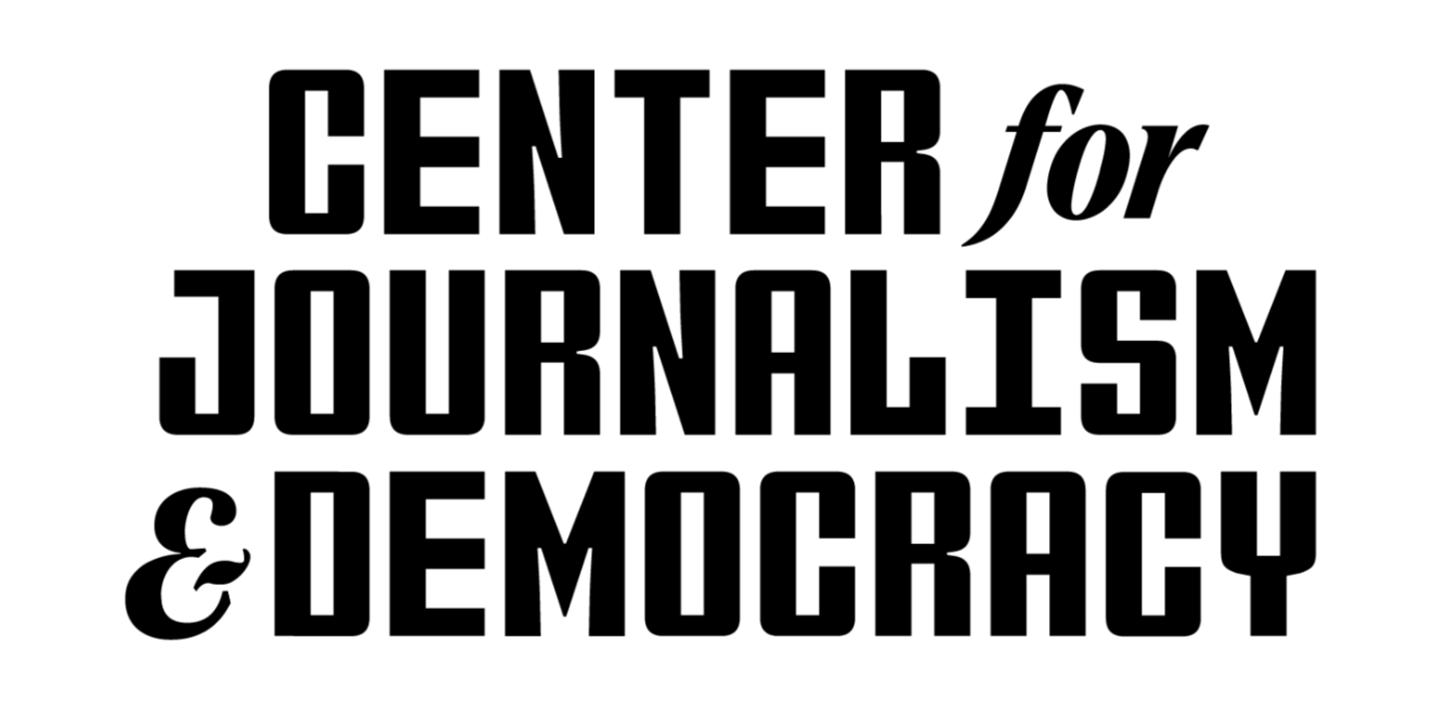

February 13, 2025

Dear Heather Cox Richardson,

We are delighted that you will participate as a speaker in the Truth Over Power speaker series, taking place on April 24 at Cramton Auditorium of Howard University. Your insights and expertise will contribute immensely to this important conversation, and we appreciate your willingness to share your perspective.

Event Details:

* **Event Name:** “Safeguarding the Press in an Age of Eroding Democracy,” the inaugural discussion of the Truth Over Power speaker series
* **Date & Time:** Thursday, April 24 | 6:00 – 8:30 PM ET
* **Location:** Cramton Auditorium, Childers Hall, 2455 6th St NW, Washington, DC 20059
* **Format:** Fireside Chat, followed by Panel Discussion
* **Livestream & Recording:** This event will be live-streamed and video-recorded for future distribution.
* **Audience:** Expected attendees include journalists, students, professionals, and the general public
* **Social Media & Promotion:** The event will be actively promoted across social media and other channels.

Event Description:

**“Safeguarding the Press in an Age of Eroding Democracy”**

The Center for Journalism & Democracy invites you to an urgent and timely conversation on the mounting challenges facing American democracy and the press.

The event will open with a **fireside chat between Pulitzer Prize-winning journalist Nikole Hannah-Jones and historian Heather Cox Richardson**, whose latest book, *Democracy Awakening: Notes on the State of America*, examines the rise of authoritarian threats, the erosion of democratic norms and the role of the press in defending truth. Richardson will discuss how the Trump administration’s ascent was part of a broader historical pattern, warning against the dangers of complacency in the face of rising authoritarianism. Hannah-Jones, an award-winning journalist and fierce advocate for press freedom, will guide this conversation, situating it within the context of ongoing attacks on journalism and the necessity of a free and independent press to sustain democracy.

This discussion will set the stage for the **panel conversation that follows, featuring journalists who have recently resigned in protest of editorial decisions they saw as compromising journalistic integrity.** As pressures on the press escalate amid political and corporate influence, this panel will offer an inside look at the realities of working in a media landscape increasingly shaped by external forces. These journalists will reflect on their departures, assess the broader state of the American press, and highlight ways to uphold press freedom as a pillar of democracy.

Honorarium & Travel Arrangements:

We will be covering your travel and accommodations and are pleased to offer a modest honorarium of $1,000. Our team will coordinate these logistics with you to ensure a seamless experience. Please provide the requested details below to facilitate this process.

Action Items for You:

To help us prepare and promote your participation, we kindly request the following information at your earliest convenience:

1. Personal and Professional Details

☐ Name (as you’d like it to appear in promotional materials)  
 ☐ Professional title & affiliation  
 ☐ Bio (100–150 words)  
 ☐ High-resolution headshot  
 ☐ Social media handles (Twitter/X, LinkedIn, Instagram, etc.)

2. Travel & Accommodation Information

☐ Preferred airport and departure city  
 ☐ Any special travel or accommodation requirements  
 ☐ Preferred arrival/departure dates (if different from the standard event itinerary)  
 ☐ Any dietary restrictions or accessibility needs

3. Panel Discussion Preparation

☐ Any specific topics or key points you’d like to emphasize (or avoid)  
 ☐ Availability for a pre-event briefing (if necessary)

☐ Submit your Photo/Video release form

**Submit your “action items” by completing this short form:** [**https://forms.office.com/r/iW0XvKcayY**](https://forms.office.com/r/iW0XvKcayY)

Event Run-of-Show:

To ensure everything runs smoothly, here is an outline of the day’s schedule.

* **Call Time:** 5:00 PM (Please arrive by this time for check-in and briefing)
* **Green Room:** Located at TBA, available for preparation and refreshments.
* **Sound Check & Tech Run:** 5:30 PM (if applicable)
* **Panel Start Time:** 6:30 PM, according to the following sequence:  
  - Welcome & Introduction (15 mins.)   
  - Fireside chat: Heather Cox Richardson and Nikole Hannah-Jones (30 mins.)  
  - Roundtable discussion: Nikole Hannah-Jones and confirmed panelists Jim Acosta, Robert Kagan, Mariel Garza (45 mins.)   
  - Q&A Session (20-30 mins.)
* **Event Close & Networking:** 8:15 - 8:30

Our team is here to support you throughout the event. If you have any questions or require additional details, please don’t hesitate to reach out. Your logistics, travel and payment contact is Solomon Brooks, Administrative Coordinator ([solomon.brooks1@howard.edu](mailto:solomon.brooks1@howard.edu) | 240-517-8397). We are thrilled to have you join us for this impactful discussion and look forward to welcoming you to Howard.

Best regards,

Kali-Ahset Amen, PhD  
Executive Director  
Center for Journalism & Democracy  
kali.amen@howard.edu  
(202) 352-4418 - mobile

CC: Lisa Adams, The Garamond Agency, lisa.adams@garamondagency.com